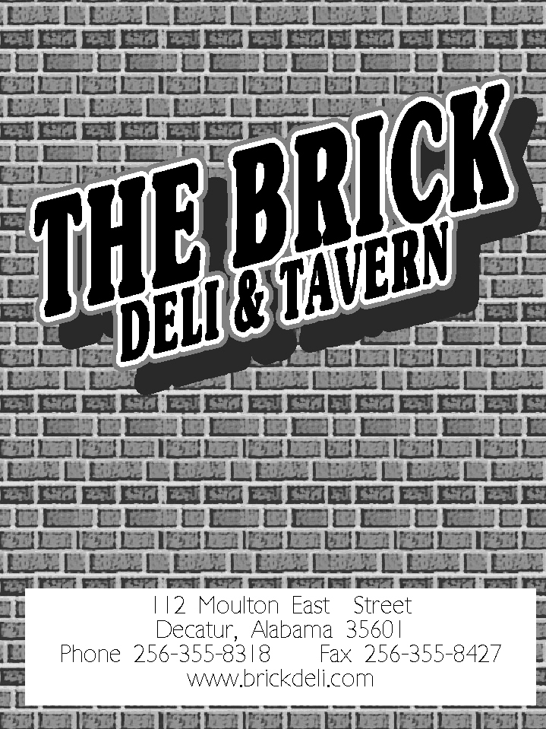
112 Moulton Street East
Decatur, AL 35601
Phone: 256-355-8318 Fax: 256-355-8427
www.brickdeli.com
Our Specialties
*ALL SANDWICHES COME WITH A PICKLE SPEAR AND CHOICE OF SIDE.
CASA DEL GRANDE  Ham, turkey, roast beef, provolone, smoked cheddar and Swiss cheeses, curry sauce, and a dash of soy sauce. All the condiments you can imagine: onions, bell peppers, mushrooms, black and green olives, lettuce and tomatoes piled high on a long white hoagie roll.  $ 10.50 | DOWNTOWN HOAGIE  Ham, turkey, salami, smoked cheddar, provolone, onions, pepperoncini, garlic powder, crushed red pepper, mayo, Italian dressing, lettuce and tomatoes all on a long white hoagie roll.  $ 10.50 | CHICAGO FIRE  Corned beef on a long white hoagie roll with mayo, hot mustard, hot pepper and Swiss cheeses, onions, jalapenos, mushrooms and tomatoes.  $ 9.50
FATHER GUIDO  A steamy pita, filled with Polish sausage, pepperoncini, onions, provolone cheese, Italian seasonings, Italian dressing, deli mustard, lettuce and tomatoes.  $ 10.00 | 5 FINGER BANJO PICKER  Polish sausage, Swiss cheese, sauerkraut, onions, jalapenos, hot mustard, and tomatoes all on toasty rye bread.  $ 10.00 | REUBEN  Toasty rye bread, steamy corned beef, Swiss cheese, sauerkraut, mayo, and deli mustard.  $ 9.25
TURKEY SURPRISE  Smoked turkey, smoked cheddar, provolone, mushrooms, curry powder,  a dash of soy sauce, mayo, and tomatoes on a fresh onion roll.  $ 9.25 | THOMPSON REUBEN  Smoked turkey, Swiss cheese, sauerkraut, mayo and deli mustard on toasty rye bread.  $ 9.25 | MELTDOWN  Sharp cheddar cheese melted over tomatoes, hot mustard, mushrooms, onions, curry powder and jalapenos  on toasty rye bread.  $ 8.00
ROB’S RYE & ROAST  Jewish rye bread, lean roast beef, hot mustard, onions, jalapenos, hot pepper cheese, mushrooms, lettuce and tomatoes.  $ 9.25 | SMOKEY JOE  Smoked turkey, smoked cheddar and Swiss cheese, bacon and thousand island dressing. Dressed with lettuce and tomatoes, piled high on toasted sourdough bread.  $ 9.50 | CASEY’S PHILLY  Long white hoagie roll, lean roast beef, mayo, Swiss cheese, onions, bell peppers, lettuce and tomatoes.  $ 9.50
AMERICAN CLUB  Toasted sourdough bread piled high with ham, turkey, bacon, American and Swiss cheeses and mayo. Topped off with lettuce and tomatoes.  $ 9.75 | COLD CLUB  Ham, turkey, salami, smoked cheddar, Swiss and provolone cheeses, mayo, deli mustard, lettuce and tomatoes on soft wheat bread.  $ 9.75 | BLEU COW  Juicy lean roast beef, bacon, our unique “bleu horsey” sauce, lettuce and tomato on toasted sourdough bread.  $ 9.50
BEEF & CHEDDAR MELT  Lean and juicy roast beef, smoked cheddar cheese, mayo, lettuce and tomatoes piled high on a warm onion roll.  $ 9.25 | DAVE’S STEAK  Marinated steak, mayo, provolone, smoked cheddar, onions, bell pepper, mushrooms, lettuce and tomatoes on a long white hoagie roll.  $ 10.50 | HONEY HAMWICH  Ham and Swiss cheese with just the right amount of honey, topped with lettuce and tomatoes on a long white hoagie roll.  $ 9.25
*Ask for your sandwich “STACKED” and get DOUBLE the MEAT for only $3.75.
*Add bacon for only $ 2.00
*Add extra cheese for only $2.00
*All sandwiches served with your choice of Potato Salad or LAYS chips: Regular, BBQ, Sour Cream & Onion, Baked, Baked BBQ, Baked Sour Cream & Onion, Fritos, Doritos, Jalapeno, and Sea Salt & Vinegar. *You can substitute a cup of soup for $3.75 or side salad for $3.25.

On the Lighter Side
BLT  Black Label bacon, mayo, lettuce & tomatoes on toasted sourdough.  $ 8.75 | GRILLED CHEESE  Texas toast with American and New York Sharp cheeses.  $ 5.50 | CUCUMBER SANDWICH  Fresh cucumbers, cream cheese, Italian seasonings, Lt. Italian dressing on wheat bread dressed with lettuce & tomatoes.  $ 8.00
BRICKYARD DOG  A 100% pure beef dog, mustard, ketchup onions, sauerkraut and our homemade hot sauce snuggled in a warm bun.  $ 6.00 | VEGGIE SANDWICH  Our in-house made veggie mix, onions, bell peppers, mushrooms, black & green olives, a blend of cheeses, curry sauce, a dash of soy sauce and tomatoes packed away in a steamy pita.  $ 8.50 | CHEESE EXTRAORDINAIRE  Steamy pita, slapped full of an assortment of cheeses, with our special curry sauce, a dash of soy sauce, onions, bell peppers, black & green olives, mushrooms, & tomatoes.  $8.50
Salads and So on…
Choice of Dressing : Ranch, Lt. Ranch, Bleu Cheese, Honey Mustard, Lt. Italian, 1000 Island, Light balsamic w/olive oil vinaigrette, Oil & vinager
Extra dressing - 65¢
SALAD SANDWICH  Chicken, Egg, or Tuna  On fresh wheat bread with provolone cheese. Lettuce and tomatoes can be added upon request.  $ 9.25 | ‘TRES PLATE  *Choose any 3 :  Potato salad, tuna salad, chicken salad, egg salad, side salad, or pimento cheese served on a bed of lettuce and tomatoes sprinkled with black and green olives.  $ 10.25 | CHEF SALAD  Fresh, crisp, Romaine lettuce, mushrooms, and fresh tomatoes, topped with ham and smoked turkey and sprinkled with shredded cheddar cheese.  $ 9.50
BLUE PLATE  Your choice of almost any ½ sandwich and a cup of soup. Sorry, no pita sandwiches.  $ 9.25 | STUFFED TOMATO  Your choice of pimento cheese, chicken, egg, or tuna salads stuffed inside a fresh tomato on a bed of lettuce with black & green olives.  $ 6.75 | GARDEN CRISP SALAD  Crisp, Romaine lettuce topped with a blend of garden veggies, cucumbers, tomatoes and sprinkled with shredded cheddar cheese.  $ 8.00
GREEN PLATE  A side salad and a cup of soup.  $ 8.75 | PIMENTO CHEESE  Freshly made, in-house, with a blend of cheddar & Swiss cheeses, and a slight hint of dill served on wheat.  $ 9.25 | SIDE SALAD  Fresh, Romaine lettuce topped with a blend of garden veggies, shredded cheddar cheese, and tomatoes.  $ 5.00

Soups CUP- $5.25 BOWL- $6.25

* ALL soups are served with Homemade Mexican Cornbread or crackers. Just tell your server which one you want.

WISCONSIN BEER CHEESE SOUP  A cup full of warm, cheesy goodness! | HOMEMADE CHILI  Delicious, homemade chili with all the stuff your grandmother uses. | CHICKEN  “LA-LA”  This chicken enchilada soup will satisfy your spicy craving. | BJ’S VEGGIE SOUP  Tomato based soup with chopped carrots, potatoes, cauliflower and broccoli. | LOADED BAKED POTATO SOUP  Creamy soup with chunks of potatoes, topped with bacon bits and shredded cheddar cheese.

For the “Independent Thinker”  Design Your Own! $ 10.50 |  |  |  | *Choose your bread, dressing, condiments, one cheese, and one meat!  -Extra meat - $ 3.75  -Extra cheese - $ 2.00  -Extra bacon (3 pcs.) - $ 2.00
BREAD  Long White Hoagie  Sourdough  Jewish Rye  Marbled Rye  Wheat  Onion Roll  Texas Toast  Pita Pocket  WRAPS  -Whole Wheat  -Tomato Basil  -Spinach | DRESSING  Honey Mustard  Mayo  Yellow Mustard  Deli Mustard  Hot Mustard  Low Fat Mayo  Ketchup  Bleu Cheese  “Horsey” Sauce  1000 Island  Ranch/Lt. Ranch  Lt. Italian | CONDIMENTS  Pepperoncini  Sauerkraut  Black Olives  Green Olives  Jalapenos  Onions  Mushrooms  Cucumbers  Bell Peppers  Lettuce  Tomatoes  Horseradish | CHEESE  American  Hot Pepper  Swiss  Provolone  Smoked Cheddar  NY Sharp Cheddar  Shredded Cheddar |  | MEAT  Smoked Turkey  Ham  Roast Beef  Corned Beef  Polish Sausage  Salami  Egg Salad  Tuna Salad  Chicken Salad  Hot Dog  Bacon
For the Sweet Tooth
HOMEMADE BANANA PUDDING  “Kennon goes crazy for a cup of this sweet treat!”  $ 5.00 |  | Dessert of the Day  Just ask your server what’s new?  “Leo loves anything sweet !!"  $ 5.00 |  | TURTLE CHEESECAKE  A graham cracker crust with cheesecake layered between chocolate and caramel!  “Madi and Liv want to slap their GrandMa, it’s so good.”  $ 6.00
Drinks | Extra Items |  | Children’s Corner
Soft Drinks…………………………….…….…….$2.75  Coke, Diet Coke, Sprite, Coke Zero, Dr. Pepper, Mello Yello, Pink Lemonade, and Fanta Orange  Coffee………………………………..….….….….……$2.75  Tea………………………………………….……………...$2.75  Juice……………………………….…….…..…..….……$3.50  (OJ, Cranberry, Pineapple, V8, Grapefruit)  No refills for juices  Red Bull (All Varieties) ……………..$3.50 | Pickles………………………………..………….……..50¢  Side of Egg, Chicken, Tuna, Potato Salads, & Pimento Cheese  ……………………………………………………………. $ 4.00  Cornbread……………………………………. $1.75  Chips….……………………………..………….….$1.75  Extra Salad Dressing……………75¢ |  | Ages 12 & under  Hot Dog (ketchup and/or Mustard)……$4.00  Peanut Butter & Jelly………….……$4.00  Grilled Cheese…………………..……….…………….…….$4.00  Meat & Cheese….………………..….……$5.00  Choose one meat & one cheese on Texas Toast.  *Comes with your choice of chips
*Gratuity of 17% may be added to tables of 6 or more.
The Brick Deli can accommodate takeout orders of all sizes. Call 256-355-8318 for information.
*Service charge of 10% is added to all to go orders of 6 or more.

